Complaint Management

Customer Retention Policy

Property and Casualty Insurance



​​

## 

**Table of contents**

**Introduction - General Retention Principles 3**

Classification of the incoming customer communications 3

Next Best Action Rules 3

**Auto Insurance 5**

Rules Applying to All Policies 5

All Risk Policies 5

Third Party Policies 5

**House Insurance 7**

Property Coverage 7

Belongings Coverage 7

**Default retention rules 8**

# 

# Introduction - General Retention Principles

This document explains which customers need to be retained and the best approach to retain them.

## Classification of the incoming customer communications

First, the last interaction with the customer should provide us some information regarding:

* Dissatisfaction level: Low, Medium, High
* Intention to leave: yes or no
* Reasons for contacting the company:
  + Bad service (affiliated tow truck or garage)
  + Claim processing time too long
  + Deductible too high
  + Accident not covered or only partially covered
  + Unsatisfied with customer service (insurance expert visit, agent, etc.)
  + Just want to get information about existing products or new products

## Next Best Action Rules

Based on the outputs of the classification and based on the customer situation (claim being processed, subscribed insurance policy), business rules will be applied to determine the next best action.

The following table lists the possible actions that can be performed to retain a customer (or not).

| **Next Best Action** | **Reason for this Action** | **Involved roles** |
| --- | --- | --- |
| Status Quo = Thank you for contacting us but… | No retention effort is justified, e.g. low profitability customers. | Contact center |
| Customer re-assigned to retention department immediately (phone interaction) or asap | Priority given to high lifetime value customers. | Reassign from the contact center to the retention dept |
| The Claims Department will contact you within X days (prioritization of pending claims, need to reassess). If not, call me back. | Assure the customer that they will get an answer quickly for their complaint. | Reassign from the contact center or the retention dept to the Claims Dept |
| Compensation related to the damage: voucher, discount on repair service with affiliated company | Policy does not cover damage but we try to minimize the cost for a valuable customer. | Contact center or retention dept |
| Upsell offer | Policy does not cover damage or includes deductible and it would make sense to upgrade policy for similar future accidents. | Contact center or retention dept |
| Prepare counter proposal against competitors | Avoid losing market share and a good customer. | Retention dept |
| Discount on next renewal | Last resort but to be avoided as it might have a negative impact on profitability. | Retention dept |

The rest of the document describes the retention rules to be applied in case of a customer complaint. The explanation codes follow a convention:

* AC = Applied Coverages
* RA = Reimbursed Amount
* HD = Handling delays
* QCS = Quality of Customer Service

# Auto Insurance

## Rules Applying to All Policies

**Discount on loaner vehicle (AC-AUTO-SUBV-DISC)**

A discount on a loaner vehicle should be granted to customers in the following situation:

* They stated they are not satisfied with the applied coverages
* Their policy does not include the “loaner vehicle” clause
* They are a very profitable customer, i.e. their CLTV percentile is at least 50%.

The amount of the proposed discount is calculated as:

10% + extraDiscountForCLTV + extraDiscountForChurner

where

* 'extraDiscountForCLTV' = (the CLTV percentile of 'the client' - 'the profitability threshold') / 2
* 'extraDiscountForChurner' = 10% if the customer shows intention to leave otherwise 0%

**Propose policy upgrade to include loaner vehicle (AC-AUTO-SUBV-UP)**

An upgrade of the policy to include a loaner vehicle clause should be proposed to customers in the following situation:

* They stated they are not satisfied with the applied coverages
* Their policy does not include the “loaner vehicle” clause
* Their propensity to upgrade their policy is at least 0.4

## 

## All Risk Policies

## Third Party Policies

**Customer responsible for damage rule (AC-AUTO-TPL)**

In case of a complaint of a customer with a third-party auto policy that is responsible for the damage, the complaint should be handled as indicated by the following tables:

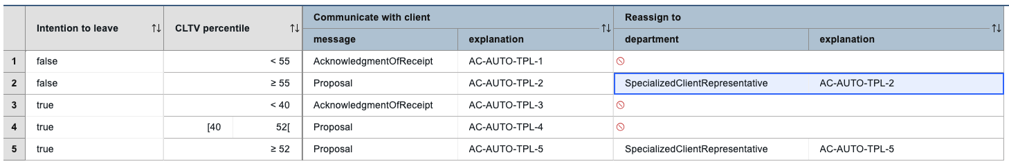

## 

# Home Insurance

## Property Coverage

## Belongings Coverage

**Example of a claim related to water damage:**

* Water damage inside an individual house due to a broken pipe.
* Insurance expert has established that the insurance policy does not cover damaged carpets (stains).
* The customer is unsatisfied (given that these carpets have sentimental value).

In such a situation and if the customer is profitable, a voucher should be provided. The actual voucher rule is as follows:

**Voucher rule (AC-HOME-CONT-VOUCHER)**

A voucher should be offered to customers in the following situation:

* Their policy covers only home structures, not the content ;
* The reason of their interaction is that they are not satisfied with the applied coverages;
* Their CLTV percentile is at least 60.

The market value of the voucher should be up to 200€ and can be used with one of our affiliate providers.

This can be applied to:

* Cleaning
* Repair services
* Etc

*The value of the voucher can be calculated depending on the cost of the repair and the CLTV percentile of the customer => make it a decision table

**Upsell rule (AC-HOME-CONT-UP)**

An upsell to the home policy should be proposed to customers in the following situation:

* Their policy covers only house structure, not the content;
* They recently said they are not satisfied with the applied coverage;
* The customer’s propensity to upgrade is at least 0.4.

Thanks to this upsell, the customer will avoid similar problems next time.

# Generic retention rules about deductibles

**Handling complaint about reimbursed amount related to high deductible (RA-DED-UP)**

In the following situation: a customer with a high CLTV percentile (at least 50) complains about the reimbursed amount and the deductible on his claims is at least 120€ and the propensity to upgrade the policy is at least 0.4

The following actions need to be performed:

* First reassign to a claims expert and tell client to call back after 8 business days if no news (this is to examine the reimbursed amount in more details)
* Once the claims expert has reassessed the claims, reassign the complaint to a SpecializedClientRepresentative suggesting "a policy upgrade to avoid deductibles"

# 

# Default retention rules

**Handling delays in answering to customer - communication (HD-CCOM)**

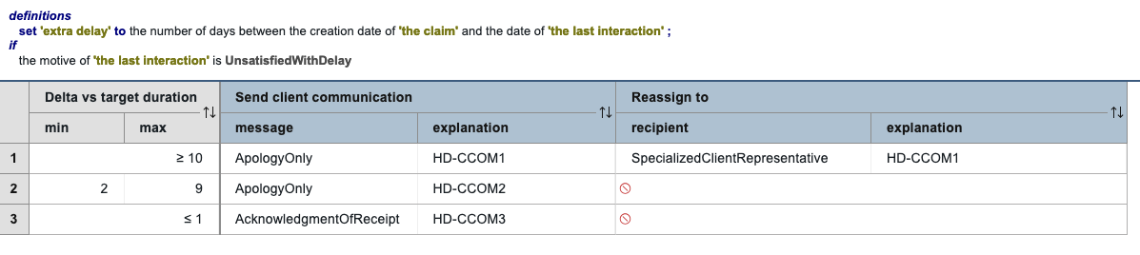

**Handling delays in answering to customer - prioritization alarm (HD-ALARM)**

Forward the complaint to a claims expert with a prioritization alarm

when the customers are in the following situation:

* They said they are not satisfied with delay taken to process their claim
* At least two days have passed since they declared the damage

**Reassign to claims expert (AC-DEFAULT)**

Forward the complaint to a claims expert with a prioritization alarm when customers are in the following situation:

* They recently said they are not satisfied with the applied coverage;

**Reassign to claims expert (RA-DEFAULT)**

Forward the complaint to a claims expert when customers are in the following situation:

* They recently said they are not satisfied with the reimbursed amount;

**Reassign to specialized client rep (QCS-HIGH-CLTV)**

Forward the complaint to a specialized client representative as "QoS Issue - look for ways to improve client satisfaction" for customers in the following situation:

* They said they are not satisfied with the quality of customer service
* their CLTV percentile of 'the client' is at least 40

**Forward to quality specialist (QCS-ALL)**

Forward to a quality specialist as "QoS Issue - look for ways to improve overall quality" for customers in the following situation:

* They said they are not satisfied with the quality of customer service